**Theory of Comp. Exercise Set 1**

1. For any $n∈N$, prove that the following equality is valid.
$$1^{6}+2^{6}+3^{6}+…+n^{6}=\frac{n}{42}\left(n+1\right)\left(2n+1\right)\left(3n^{4}+6n^{3}-3n+1\right)$$

2. Let $α$ and $β$ be two positive integer numbers. If $α^{2}-β^{2}$ is not odd, then prove that $α+β≥2$.
3. Let $a,b,c,d$ be integers. If $a>c$ and $b>c$, then prove that $\max{(a,b)}-c$ is always positive.
4. Given two sets $X$ and $Y$. The Cartesian product of $X$ and $Y$, written as $X×Y$, is defined as the set of pairs $(x,y)$ where $x∈X$ and $y∈Y$. Let $|X|$ be number of elements in $X$. Then, find a mathematical closed-form expression to write $|X×Y|$ in terms of $|X|$ and $|Y|$.
5. X and Y are two disjoint sets. U is union of X and Y. Sum of the elements in a set A is s(A) and product of elements in a set A is p(A).
   1. Find s(U) and p(U) in terms of s(X), s(Y), p(X), p(Y).
   2. Conclude from this what s({}) and p({}) should be ({} is empty set).
6. The following is the state diagram of DFA M. Answer the following questions about M. What sequence of states does the machine go through on input *aabb*?

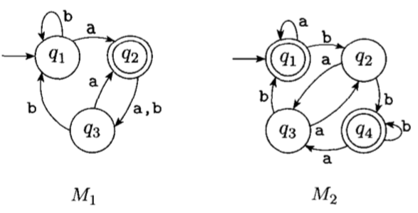

1. The formal 5-tupple description of a DFA M is $\left(\left\{q_{1},q_{2},q_{3},q_{4},q_{5}\right\},\left\{u,d\right\},δ,q_{3},\left\{q_{3}\right\}\right)$, where transition function is given by the following table. Draw the state diagram of this machine.

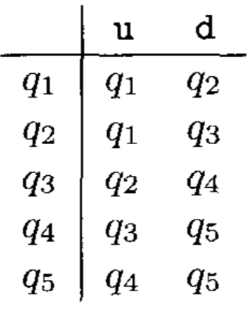

1. Draw state diagrams of DFAs recognizing the following languages. In all questions the alphabet is $\{0,1\}$.
2. {w | w begins with a 1 and ends with a 0}
3. {w | w contains at least three 1s}
4. {w | w contains the substring 0101, i.e., w = x0101y for some x and y}
5. {w |w has length at least 3 and its third symbol is a 0}
6. {w | w starts with 0 and has odd length, or starts with 1 and has even length}
7. {w | w doesn't contain the substring 1101}
8. {w | w the length of w is at most 5}
9. {w | w is any string except 11 and 1111}
10. {w | every odd position of w is a 1}
11. {w | w contains at least two 0s and at most one 1}
12. {e, 0}
13. {w | w contains an even number of 0s, or contains exactly two ls}
14. {}
15. All strings except the empty string
16. Show by giving an example that if M is a DFA that recognizes language C, swapping the final and non-final states in M yields a new DFA that recognizes complement of C.
17. Design automata (DFA) to accept the given languages.
18. A = {w {0, 1}* : w has a 1 in the third position from the right}. Hint: question is hard if you try to draw DFA directly. Start with NFA, then convert to DFA.
19. B = {w {0, 1}* : w contains at least two 0s}
20. C = {w {0, 1}* : the length of w is divisible by three}
21. D = {w {0, 1}* : w contains exactly two 0s and at least two 1s}.
22. Give state diagrams of NFAs with the specified number of states recognizing each of the following languages. In all parts the alphabet is {0,1}.
23. The language {w | w ends with 00} with three states
24. The language {w | w contains the substring 0101, i.e., w = x0101y for some x and y} with five states
25. The language {w | w contains an even number of 0s, or contains exactly two ls} with six states
26. The language {0} with two states
27. The language $0^{*}1^{*}0^{+}$ with three states
28. The language $1^{*}{\left({001}^{+}\right)}^{*}$ with three states
29. The language $\{ε\}$ with one state
30. The language $0^{*}$ with one state
31. **C**onvert the following two non-deterministic finite automata to equivalent deterministic finite automata.
32. 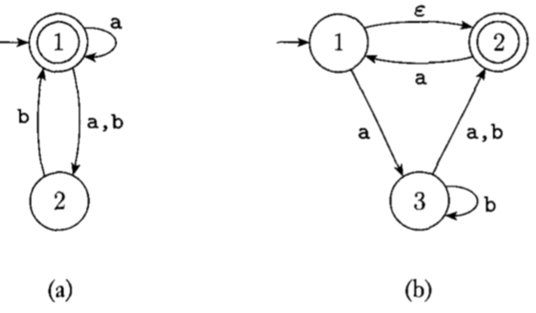
33. Diagram

    Description automatically generated
34. Convert the NFA given in previousDiagram

    Description automatically generated
35. Give regular expressions describing the given languages. Try writing without looking at the options.

$A=\{w∈{\left\{0,1\right\}}^{*} : w \text{contains at least three} 1s\}$.

$B=\{w∈{\left\{0,1\right\}}^{*} : w \text{contains at least two} 1s \text{and at most one} 0\}$,

$C=\{w∈{\left\{0,1\right\}}^{*} : w \text{contains an even number of} 0s \text{and exactly two} 1s\}$. $$D=\{w∈{\left\{0, 1\right\}}^{*} : w \text{contains an even number of }0s \text{and each} 0 \text{is followed by at least one}\text{ 1}\}$$

1. Design a DFA or NFA for the following languages. n0(w) denotes the number of zeros in the string w.
2. L1 = {w  {0, 1}* : n0(w) mod 2 = 0 },
3. L2 = {w  {0, 1}* : n0(w) mod 3 = 0 }
4. Based on using the NFA and DFA you designed in the options A and B, design an NFA that recognized the language L3 = {w{0, 1}* : n0(w) mod 6 = 0}.

Hint: De Morgan's Laws can be used for designing an NFA that recognizes the intersection of languages.